Chris Ritter is the author of "Seven Things John Wesley Expected Us to Do for Kids" (Abingdon Press, 2016). He is the Directing Pastor of Geneseo First United Methodist Church which has been honored both by the Illinois Great Rivers Conference and Discipleship Ministries for its high number of new professions of faith. An ordained elder, Chris graduated magna cum laude from Candler School of Theology at Emory University and earned a Doctor of Ministry degree from Perkins School of Theology at Southern Met
https://en.gravatar.com/critter1969
https://www.peopleneedjesus.org/
https://www.facebook.com/GeneseoFUMC/
https://www.facebook.com/ritter.chris
https://twitter.com/RitterChris

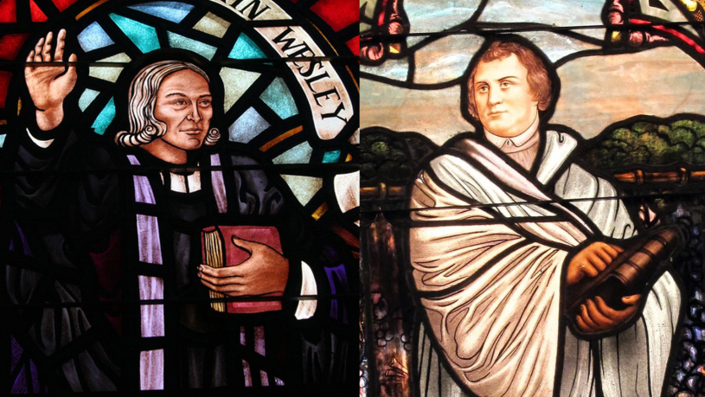

John Wesley’s heart was strangely warmed at an evening meeting on Aldersgate Street as someone read aloud from Martin Luther’s Preface to the Book of Romans. Every Methodist worth his/her salt knows this, right? That night, Wesley said that he went from the faith of a slave to the faith of a son. His thirty-five years leading up to this moment would later be described by him as the frosty and frustrated life of an “almost Christian.”

This spiritual thaw was a reaction to the then 200-year-old words of Luther “describing the change which God works in the heart through faith in Christ.” J.A. Faulkner suggests those words in Luther’s Preface to Romans were these:

「
Faith is a living, unshakeable confidence in God’s grace; it is so certain, that someone would die a thousand times for it. This kind of trust in and knowledge of God’s grace makes a person joyful, confident, and happy with regard to God and all creatures. This is what the Holy Spirit does by faith.
」

Wesley’s big moment in the Moravian meeting room is best understood within the context of a longer season of exposure that Wesley had to these German Christians and their leader, Peter Boehler. Wesley was impressed by the faith of the Moravians during an Atlantic storm on his way to America. On his miserable journey back home, the defeated Wesley found a spiritual mentor in Boehler. For the first time in his life, Wesley was introduced to the idea of instantaneous conversion, a concept Boehler traced back to scripture through Luther. This 26-year-old Moravian would make a thorough Protestant out of his new high church friend.

Back in London, Boehler convinced Wesley that he did not possess “the full Christian salvation.” This realization on March 5, 1738 is sometimes called Wesley’s “intellectual conversion.” Convinced of his own unconverted state, Wesley resolved to quit preaching. Boehler instead advised him to preach faith until he had it. He also convinced Wesley to begin praying and preaching extemporaneously. The very next day Wesley began publicly declaring an instantaneous work of saving grace that he knew he did not have.

A week after Aldersgate, Wesley praised Luther in a sermon on “Salvation by Faith” at St. Mary’s in Oxford, calling him “the champion of the Lord of Hosts, Martin Luther.” In a later sermon, Wesley said this about Luther:

「
When iniquity had overspread the church as a flood, the Spirit of the Lord lifted up a standard against it. He raised up a poor monk, without wealth, without power, and at that time, without friends, to declare war, as it were, against all the world; against the bishop of Rome and all his adherents. But this little stone being chosen of God, soon grew into a great mountain and increased more and more till it had covered a considerable part of Europe. (from Wesley’s sermon “The Wisdom of God’s Counsel”)
」

Later in life, Wesley would refer to Luther as a “much greater man” than himself.

One Bro Shy of a Bromance
Wesley’s admiration of Luther was not without serious qualifications. In the same sermon quoted above, Wesley outlined how Luther’s movement failed to realize a sustained legacy of transformed hearts:

「
Yet even before Luther was called home the love of many was waxed cold. Many that had once run well turned back from the holy commandment delivered to them; yea, the greater part of those that once experienced the power of faith made shipwreck of faith and a good conscience. The observing this was supposed to be the occasion of that illness a fit of the stone whereof Luther died after uttering these melancholy words, “I have spent my strength for naught. Those who are called by my name are, it is true, reformed in opinions and modes of worship, but in their hearts and lives, in their tempers and practice, they are not a jot better than the Papists.” (Sermon, “The Wisdom of God’s Counsel”)
」

Wesley’s disappointment with Luther was not limited to the waning spiritual effectiveness of his Reformation. He viewed Luther’s basic theology as defective, particularly his treatment of sanctification. (Some of this souring may have coincided with Wesley’s falling out with the Moravians.) Wesley’s first recorded negative comment about Luther was in 1739, a year after Aldersgate. In promoting the spiritual value of small groups, Wesley argued, “How dare any man deny this to be (as to the substance of it) a means of grace, ordained by God? Unless he will affirm (with Luther in the fury of his Solifidianism) that St. James’s Epistle is ‘an epistle of straw. ‘” Solifidianism (I had to look it up) is the belief that faith alone, without good works, is sufficient for salvation.

In his sermon “On God’s Vineyard,” Wesley argued:

「
Who has wrote more ably than Martin Luther on justification by faith alone? And who was more ignorant of the doctrine of sanctification, or more confused in his conceptions of it? In order to be thoroughly convinced of this, of his total ignorance with regard to sanctification, there needs no more than to read over, without prejudice, his celebrated comment on the Epistle to the Galatians.
」

Wesley was extremely disappointed when reading Luther’s Commentary on Galatians. He critiqued his thoughts as “confused”, “deeply tinctured with Mysticism” (denying a prominent place for reason) and “dangerously wrong.” Although Wesley eventually came to accept the Lutheran doctrine of imputed righteousness (an alien righteousness given to the believer upon faith in Christ), Wesley could not accept that Jesus came to make us technically righteous. Christian salvation is to make us actually righteous… or else it is not the real deal.

Wesley’s final disappointment with Luther was with his character. Luther’s rough edges and bombastic manner are notorious. To whom shall we compare Luther? Let’s just say we can be thankful that he did not have a Twitter account. (For a taste of Luther’s venom, visit the Lutheran Insult Generator and hit the “Insult Me” button a few times.)

Yes, it seems that Wesley was not only disappointed in Luther’s theology of sanctification but also his personal practice of it. Wesley wrote in his journal:

「
Wednesday, July 19 [1749]–I finished the translation of Martin Luther’s Life. Doubtless he was a man highly favored of God and a blessed instrument in His hand. But oh! what pity that he had no faithful friend! None that would, at all hazards, rebuke him plainly and sharply, for his rough, intractable spirit, and bitter zeal for opinions, so greatly obstructive of the work of God!
」

Wesley was disappointed in Luther’s friends that they did not knock off his rough edges. Some of those “Table Talk” conversations could have done with less beer and more “iron sharpening iron”. As Leo Cox commented, “Apparently Wesley would like to have gotten Luther into one of his class meetings.”

I wonder how that would go.

Some Sources:

http://www.emk.de/meldungen-2016/luther-und-wesley-eine-seelenverwandtschaft/

http://resources.thegospelcoalition.org/library/john-wesley-s-view-of-martin-luther

http://www.etsjets.org/files/JETS-PDFs/7/7-3/BETS_7_3_83-90_Cox.pdf

http://archives.gcah.org/xmlui/bitstream/handle/10516/5074/MH-1981-October-Walls.pdf?sequence=1

http://hopemoraviannc.org/MoravianChurch.htm

http://www.ccel.org/l/luther/romans/pref_romans.html

Faulkner, John Alfred. “Wesley’s Attitude Toward Luther” The Lutheran Quarterly Review, Volume 36, 1906.

Photo Credits:

http://www.umc.org/who-we-are/methodism-quiz-what-is-john-wesleys-birthday-on-current-calendars

